Database Management — PostgreSQL
OMOP / OHDSI training · Wednesday 16 September 2026 · Connect → empty table → import CSV → first queries
1. Register the server
In pgAdmin, register a new server. On the General tab, set Name to OMOP Training — that name is only a label in the sidebar. On the Connection tab, enter Host, Port, Username and Password. Those fields are the login.
Values to enter
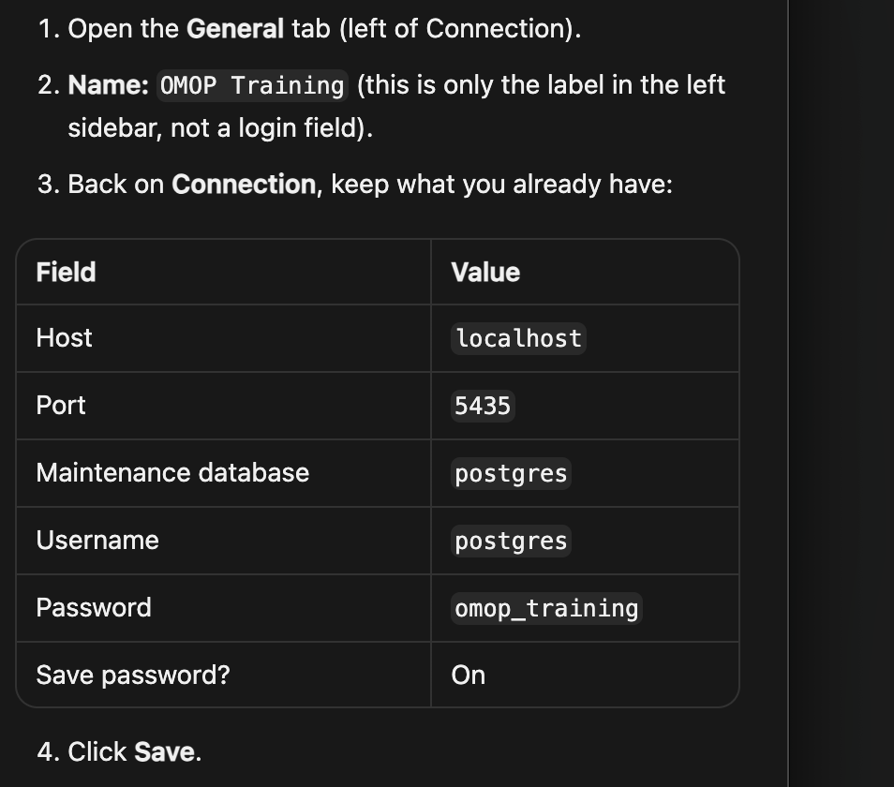
Completed connection
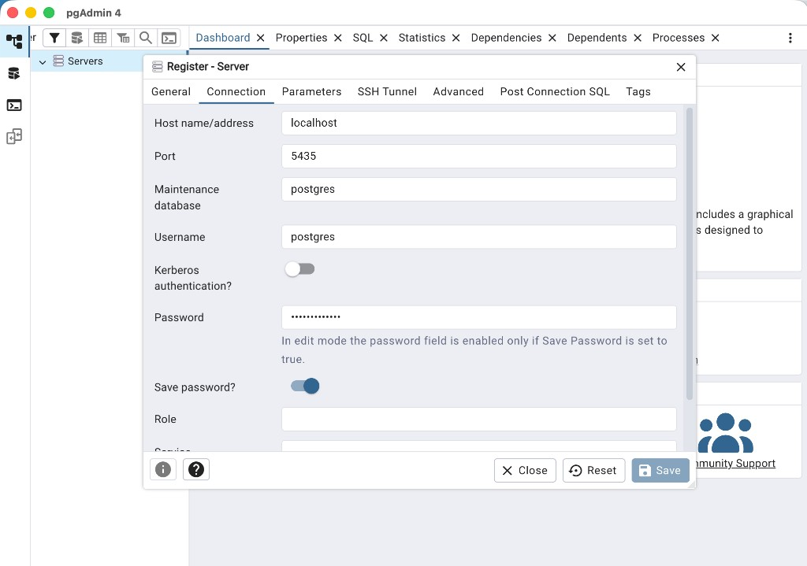
Enter localhost, port 5435, username postgres, password omop_training. Turn Save password on, then click Save.
2. Connected — OMOP Training
Confirm OMOP Training appears under Servers. Skip the Configuration tab. Under Login/Group Roles, the pg_* names are system roles — leave them unchanged. The login role for this session is postgres.
Next clicks
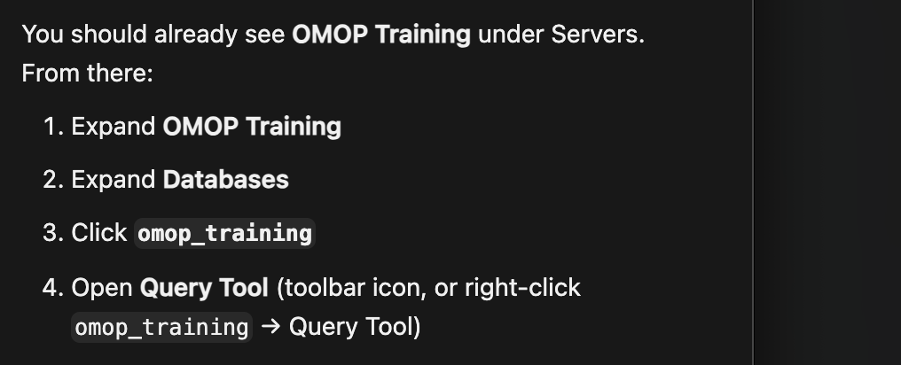
Connected server
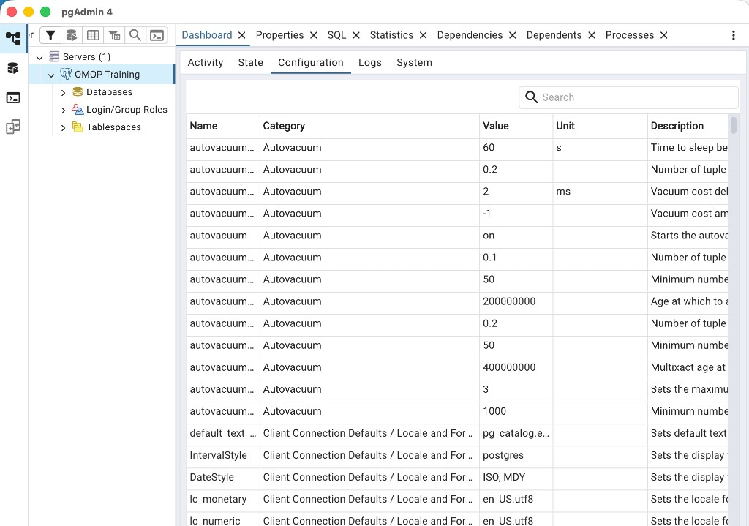
Login/Group Roles
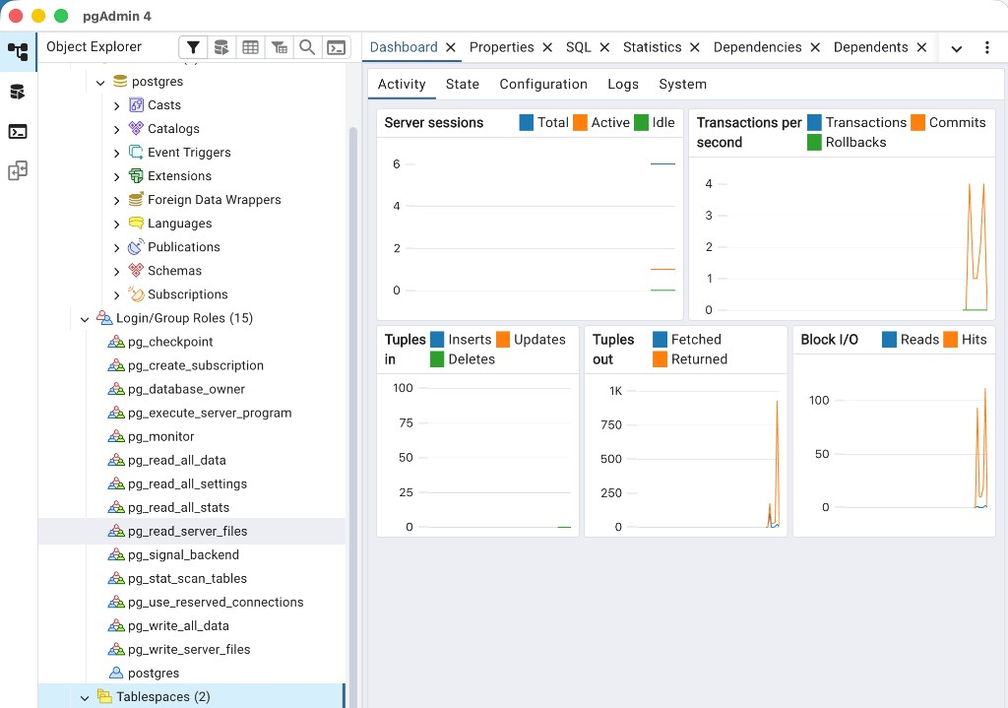
Do not edit pg_monitor, pg_read_all_data, or the other pg_* roles.
3. Create database omop_training
postgres is the default maintenance database. Do not load the training CSV there. Right-click the Databases folder (not the postgres database itself) and create omop_training.
Create the database
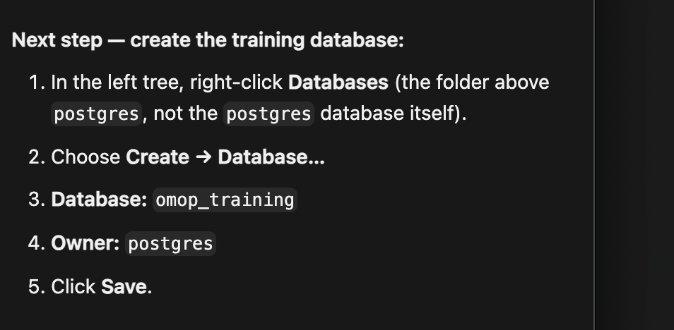
Databases (2)
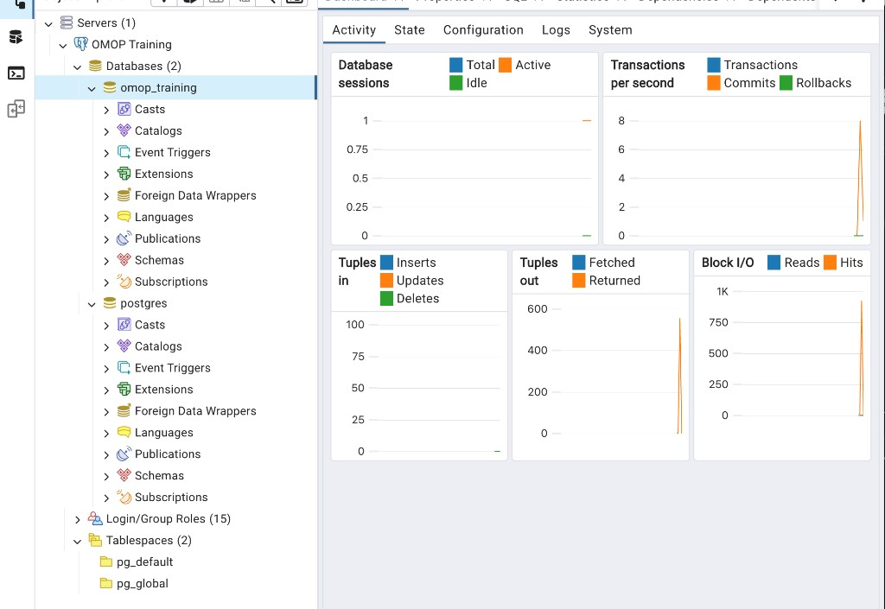
Use omop_training for all remaining steps. Leave postgres as it is.
4. Open Query Tool and check the connection
Open Query Tool from omop_training. Check the top bar: it must read omop_training/postgres@OMOP Training. If it shows postgres@…, close that tab and open Query Tool from omop_training. A result of inet_server_port 5432 is normal inside Docker. The pgAdmin connection stays on port 5435.
Open Query Tool
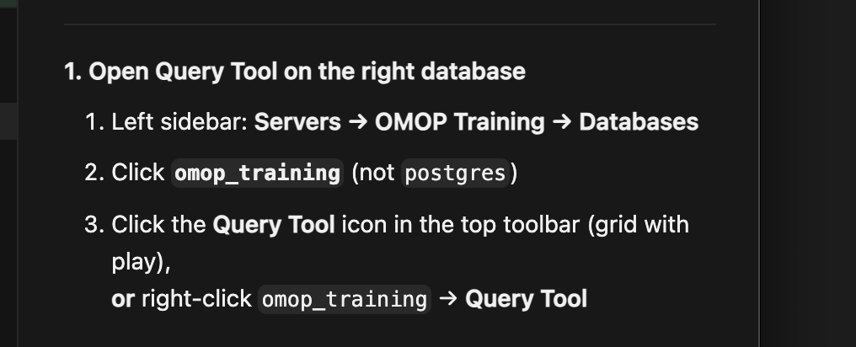
Connection check
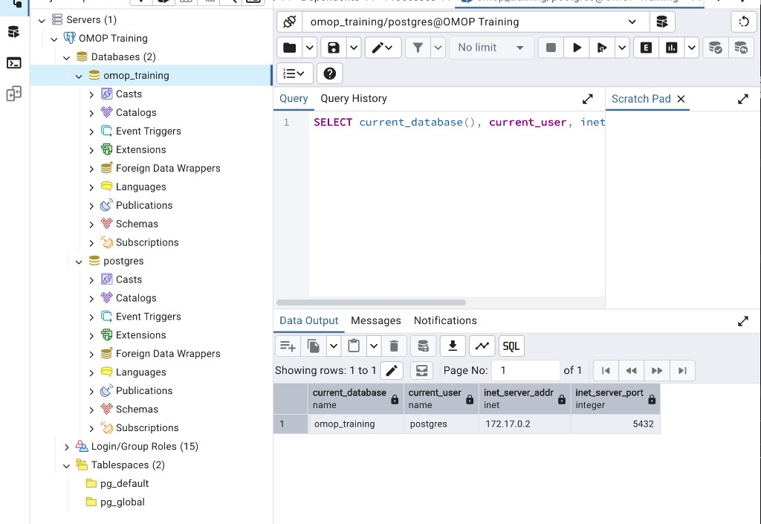
Success looks like current_database = omop_training and current_user = postgres.
5. Create the empty table survey
SQL queries a table, not the CSV file. CREATE TABLE builds the empty grid (column names and types, 0 rows). Copy the SQL below into Query Tool on omop_training. Do not type all 44 columns by hand.
SQL — CREATE TABLE survey
-- Paste this in Query Tool on database: omop_training
-- This only CREATES the empty table. It does not load the CSV.
DROP TABLE IF EXISTS survey;
CREATE TABLE survey (
pid integer,
wave_id text,
interview_date date,
date_of_birth date,
prov2001 text,
best_gen text,
best_race text,
age_yrs numeric,
age_group text,
education_status text,
marital_status text,
occupation_status text,
a_rel text,
a_emobth text,
a_emomnd text,
a_emodep text,
a_emoeff text,
a_emohope text,
a_emofear text,
a_emoslp text,
a_emohap text,
a_emolone text,
a_emogo text,
cesd_total_score integer,
cesd_depression text,
adult_bmi numeric,
adult_bmi_group text,
adult_waist numeric,
adult_bp_systolic numeric,
adult_bp_diastolic numeric,
adult_bp_pulse numeric,
a_hltb text,
a_hlbp text,
a_hldia text,
a_hlstrk text,
a_hlast text,
a_hlhrt text,
a_hlcan text,
hiv_aids text,
epilepsy text,
country text,
producer text,
interviewer_id integer,
interviewer_gender text
);
Paste and run
Paste the script
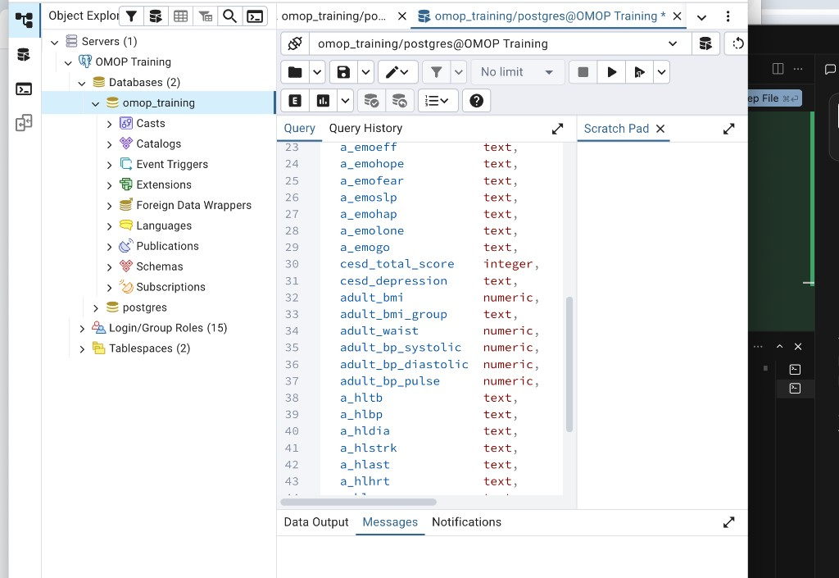
In Query Tool, paste the SQL, then click the play button or press F5.
Messages
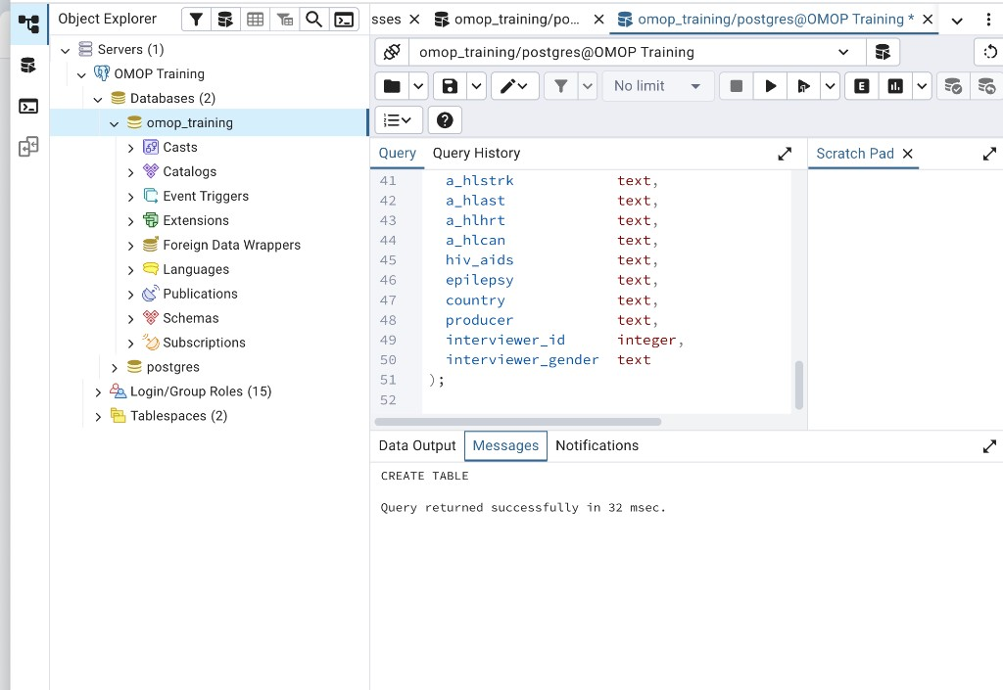
Look for CREATE TABLE and Query returned successfully.
Confirm the table is empty
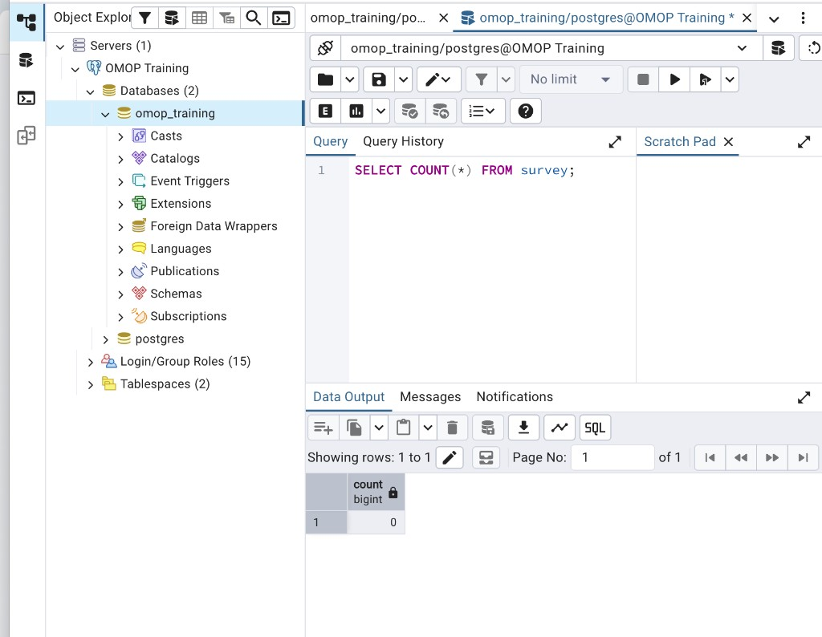
COUNT must be 0 before import. Then continue to the next step.
6. Find survey in the tree
The survey table is not listed next to Databases. Expand Schemas → public → Tables. If survey is missing, right-click omop_training → Refresh, then expand again.
Find the table
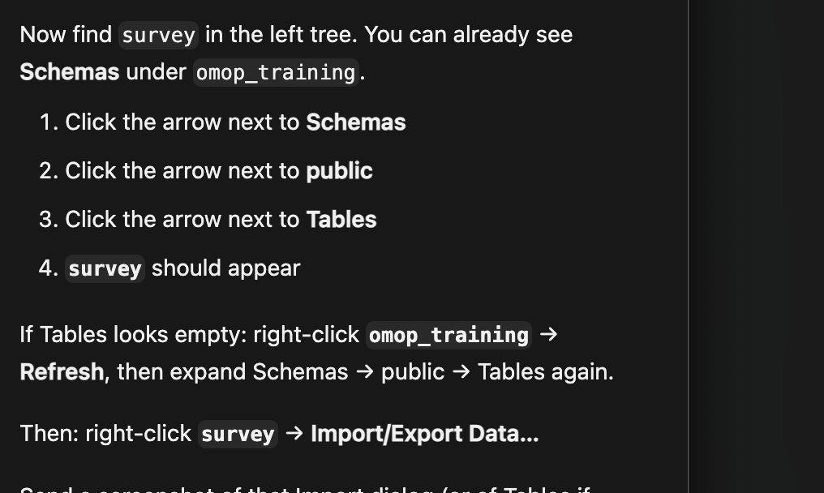
survey under Tables
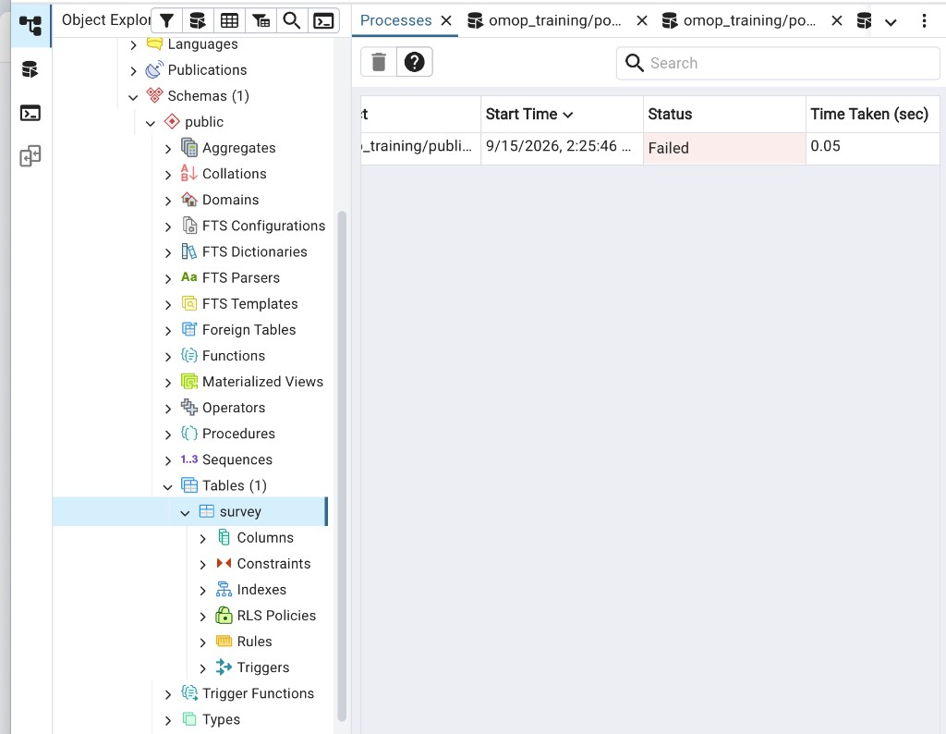
Right-click survey → Import/Export Data.
7. Import sample_data.csv
Import copies the CSV into table survey. After import, run SQL against survey only. On Options, set Header to Yes so the first row is treated as column names.
Import path
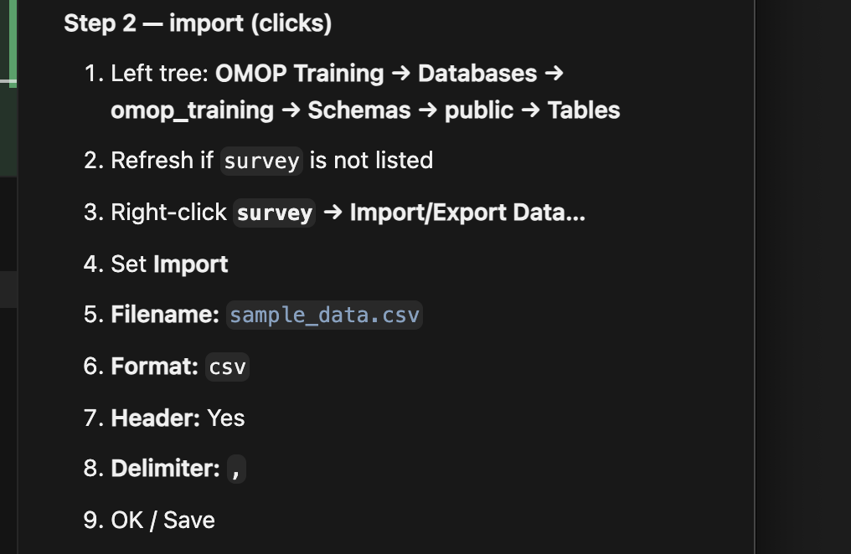
General tab
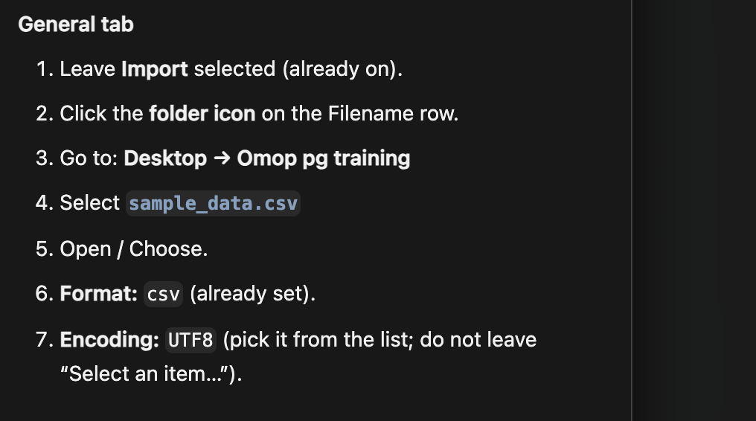
Filename is required
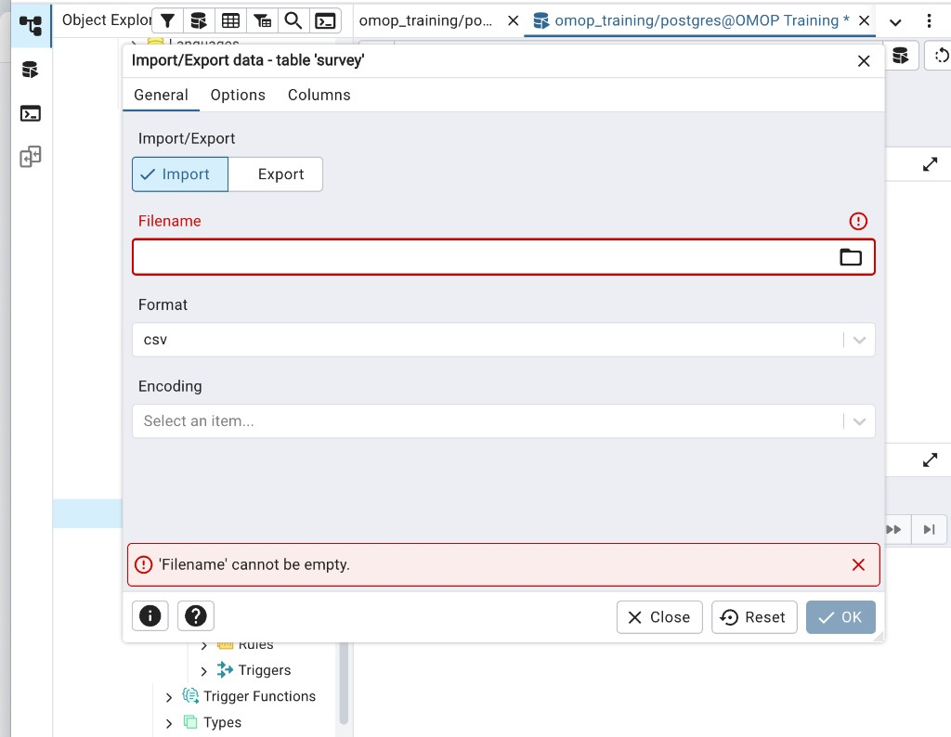
If Filename is empty, click the folder icon and choose the CSV. Do not click OK yet.
File selected
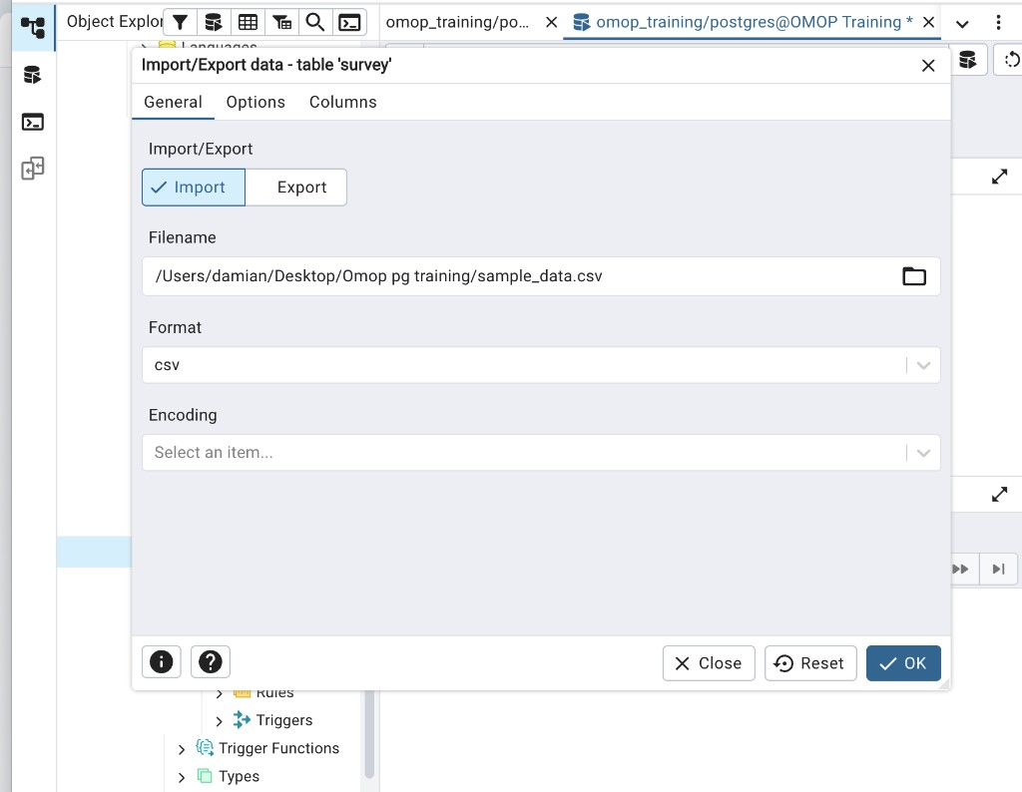
Choose sample_data.csv. Format = csv. Set Encoding to UTF8 before OK.
Encoding and Options
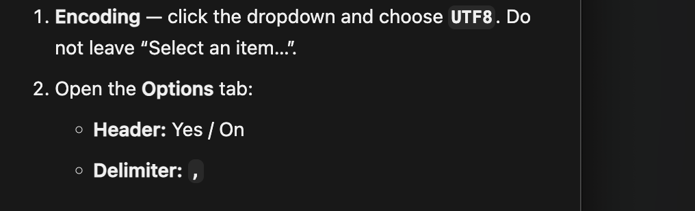
If Import fails
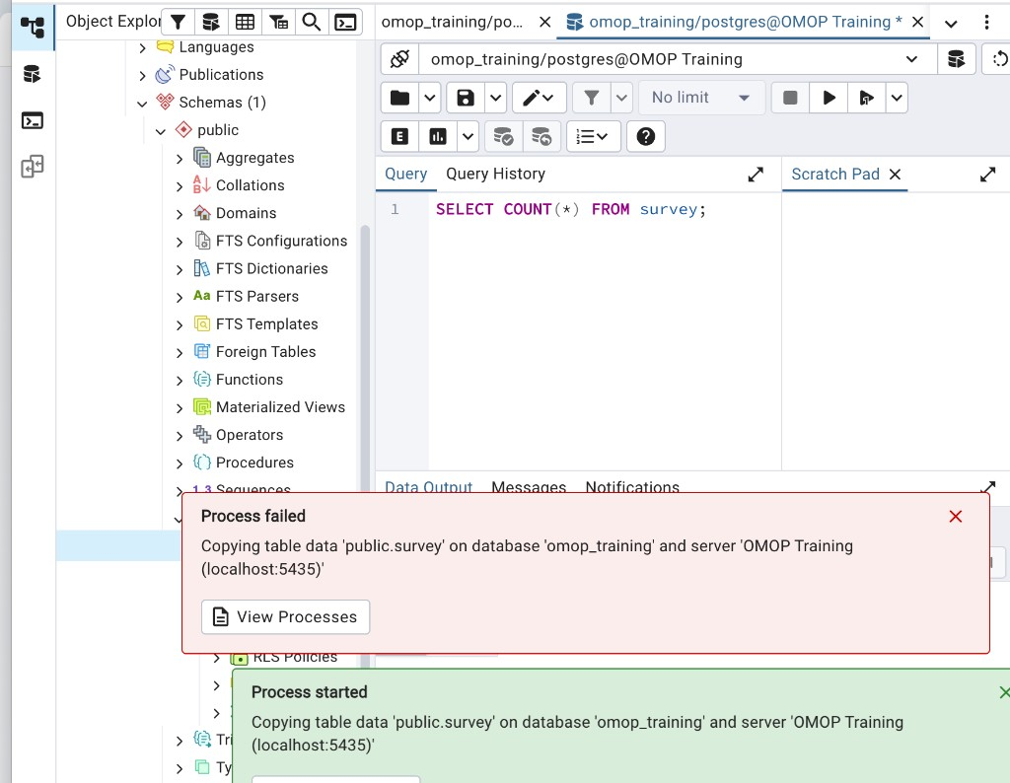
This CSV uses day/month dates (for example 16/08/2012). Postgres may expect month/day, which makes 16 an invalid month. Run the SQL below once, disconnect and reconnect OMOP Training, then Import again.
ALTER DATABASE omop_training SET datestyle TO 'ISO, DMY';
Confirm the load
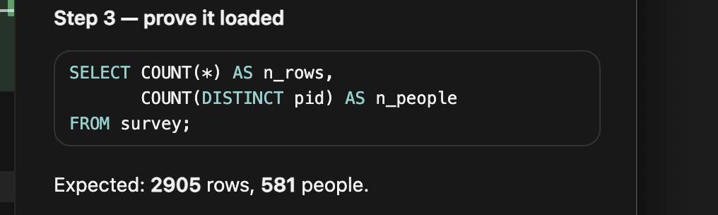
8. First query — SELECT * LIMIT 10
SELECT * returns every column. LIMIT 10 returns only 10 rows — run this first on a new table. The dataset has 2,905 rows: 581 people × 5 waves (w1–w5). The same pid across five rows is one person over time. This is source data, not OMOP CDM.
First 10 rows
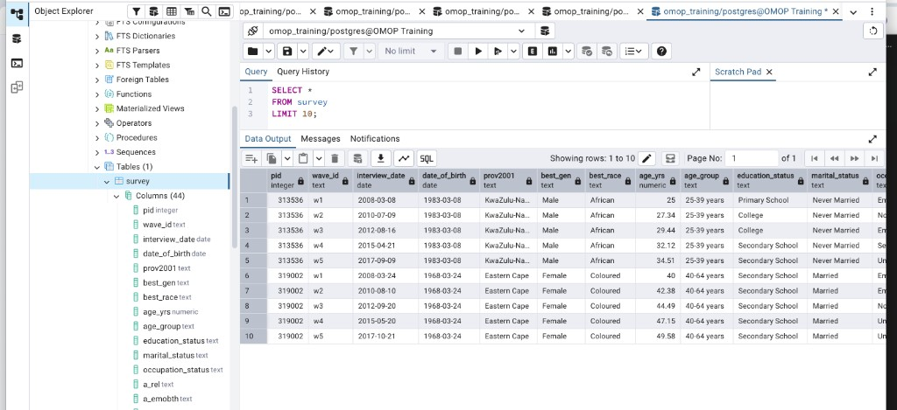
Dates display as 2008-03-08. In the CSV they were 08/03/2008. Same date.
9. More SQL on survey
Stay in Query Tool on omop_training. Paste one query, run it, then go to the next. SELECT chooses columns. WHERE chooses rows. Keep LIMIT unless the query is a COUNT.
SELECT specific columns
SELECT pid, wave_id, best_gen, age_yrs, education_status
FROM survey
LIMIT 10;
WHERE — filter rows
SELECT pid, wave_id, best_gen, age_yrs, prov2001
FROM survey
WHERE best_gen = 'Female'
LIMIT 10;
WHERE + AND — two conditions
SELECT pid, wave_id, age_yrs, prov2001, adult_bmi
FROM survey
WHERE best_gen = 'Female'
AND age_yrs > 40
LIMIT 10;
Missing data — IS NULL (do not use = NULL)
SELECT pid, wave_id, adult_bmi, adult_bmi_group
FROM survey
WHERE adult_bmi IS NULL
LIMIT 10;
ORDER BY + LIMIT — sort
SELECT pid, wave_id, age_yrs, adult_bmi
FROM survey
WHERE adult_bmi IS NOT NULL
ORDER BY adult_bmi DESC
LIMIT 10;
COUNT and DISTINCT
SELECT COUNT(*) AS n_rows
FROM survey;
SELECT COUNT(DISTINCT pid) AS n_people
FROM survey;
SELECT DISTINCT wave_id
FROM survey
ORDER BY wave_id;
GROUP BY — rows per province
SELECT prov2001 AS province,
COUNT(*) AS n_rows
FROM survey
GROUP BY prov2001
ORDER BY n_rows DESC;
HAVING — filter groups
SELECT prov2001 AS province,
COUNT(*) AS n_rows
FROM survey
GROUP BY prov2001
HAVING COUNT(*) > 300
ORDER BY n_rows DESC;
One question in one query
SELECT pid,
age_yrs,
prov2001,
adult_bmi,
adult_bmi_group
FROM survey
WHERE wave_id = 'w5'
AND best_gen = 'Female'
AND adult_bmi IS NOT NULL
ORDER BY adult_bmi DESC
LIMIT 10;
Files for this session
01_create_survey_table.sql — paste this in Query Tool to create table survey. sample_data.csv — import this file into survey. 02_sql_queries_stepwise.sql — extra SELECT / WHERE / GROUP BY practice.

